11. **Implementation of Data Encryption and Anonymization.**

1. Importance of Data Encryption and Anonymization:

Readable data is changed to an unreadable form using encryption keys and techniques. The fact is that you will encrypt your data such that any user without cryptographic decryption keys cannot read or decrypt them. Such data as financial transactions, personal customer details among other things are subjected to cryptography in order to shield them against fraud and related cases. It refers to the process of removing or anonymizing PII from a dataset in order to safeguard your privacy. It also protects personal information from being linked to particular data point. This has even been more true in matters of data sharing and privacy during analysis sessions. These security measures in this project report, including, the business objectives of the project report relate directly to Lorbek Cars Showroom Online. It is advisable to introduce the appropriate and safe systems to alleviate fears about personal information, payments, and customer details.

1. Implementation in Lorbek Cars exhibition:

2.1 *Encryption Implementation*:

• Data encryption is indispensable for holistic security in several system components. Here are some examples of where encryption may be used:

• Client Data: We use encryption to protect all client data in our databases (names, contact details, and addresses). Furthermore, even when the database is compromised, crucial information cannot be retrieved without the decryption key.

• Payment Information: Such data includes credit cards numbers as well as the transaction. This ensures security of online transaction and your money.

• User Authentication: Employ password encryptions for login credentials so as not to allow unauthorized users to gain access into these user accounts. They also use secure hashing algorithms for encryption of passwords.

• End-to-end encryption protects data as it passes over the communication line from the user interface to the server. The application of Transport Layer Security and Secure Sockets Layer technologies is intended to provide secure communication channels.

• Encryption should also be considered for the exporting of reports as PDF, Excel, or CSV files. This ensures that the private aspects of your message are safe even when you have forwarded it for other people.

2.2 *Anonymization Implementation*

If you want to protect the confidentiality of clients’ data and be in line with legislation concerning this issue, you should include a special anonymity plan into your research work. The following are the most critical aspects of anonymization:

• Customer Data: PII should also be removed for customers’ records including their names, addresses, and phone numbers. We use anonymous identifiers that enable us to trace back to the profiles for the sake of anonymity. • Transaction history: We can remove or encrypt individual data contained in transactional records to de-anonymize such records. It ensured continued preservation of the privacy and analytics relevancy for existing history information.

• Exported reports: Anonymization technology is used before exporting the reports. Sometimes important data may have to be deleted or expunged before disclosure to the proper recipients such as stakeholders or authorities.

• Sanitize user logs to mask users’ and system administrators’ identities. This guarantees that in the course of the security clearance process people’s personal data will not be revealed.

1.2 **Purpose of Project**

The purpose of this Lorbek Car Showroom Management System project is to overhaul and automate the routine functions of the conventional hand-written mode. This software-based solution focuses on addressing the shortfalls inherent in the existing approach by establishing a modern, user friendly platform that solves all problems pertaining to managing data relating to cars, customers, payment, insurance, booking, and loan.

On a fundamental level, this project seeks to supersede the conventional manual system used in Lorbek’s Car Showroom. It intends to bring a modern digital framework to avoid common mistakes, ease the challenges related with data input, as well as simplify all complicated aspects present in the current operational set-up. This approach is based on careful arrangement of information and strong operability, which makes it retrievable or modifiable at any time.

Advanced search functionality considering numerous aspects like Car, Loan, booking, and customer would help in acceleration of data retrieval hence improving customer experience and operational speed.In addition, the program shall validate all inputs eliminating chances of input of faulty data which will be reported immediately enhancing data accuracy.

1.3 **Objective of the Project:**

The Lorbek Cars Showroom Management System aims at upgrading traditional showroom processes into an efficient and error-free electronic system. Design of the system intends to address weaknesses in manual systems particularly keeping records of car, customer, payment, insurance, loan etc.

This project aims to address the problems of the existing manual system at its heart. A key goal in this regard is to reduce data entry errors by a magnitude of order. The system validates all data that is fed into it and provides clear error message for invalid inputs in order to make accurate data-entrying and management possible. However, it lies on developing an amicable interface that does not require expert knowledge to enable smooth navigation. Its intuitive design intends to make interaction between the user and the system easy, thereby allowing for efficiency of the entire project framework. The software automates tasks while providing a platform for sharing information to enhance speed in business. Optimising resource is one of the key purposes – improving use of resources within the showroom and reducing data entry processes. This should help the workers to focus on what they do best and assist in good resource management as well as allocation.

The project will also have remote access option that will facilitate easy operation even when moving away from the station. This functionality offers flexibility for busy executives and users allowing them to continue keeping tabs with their showroom operations.

Overall, the main purpose of implementing the Lorbek Cars Showroom Management System would be to develop a strong, reliable and practical tool for centralized information control as well as increasing the working rate of the showroom. The project’s goal is to help support the growth of the showroom in the future by adapting strategies that can make sure that the showroom has been prepared enough for the challenges and goals it will face.

1.4 Scope and Limitation

It is expected that the LorbekCars Showroom Online System would transform the day-to-day activities of the showroom by automating different functions such as car management, customer management, payment management, insurance management, booking management, and loan management. Nonetheless, just as every undertaking, this system possesses clearly-staked borders and restrictions that demarcate its space and restraints.

**Scope:**

* Comprehensive Data Management: The system provides a comprehensive and integrated platform for managing data on Cars, Customer information, payments, insurance details, and loans. The design is meant to aid in quick browsing, editing, and referencing of the data.
* User-Friendly Interface: Usability has been a priority in the design of the system for easy use. The application allows users, even those with no technical knowledge, navigate it effectively and avoid mistakes during data entry, which increases efficiency.
* Search and Filter Functionality: Searching is robust enough so that a user can quickly locate Cars, Loans, Bookings and Customer’s details using many fields as well.
* Report Generation: It also enables report generation that can be extracted using different formats like PDF, Excel or CSV in the areas of Cars’ payments, insurance, loans, bookings, customer details among others.
* Error Handling and Validation: Validation means exclude any fake input information that is unacceptable for the validity of the database record. These are prompts for error which help in correcting mistakes made by users when entering the data.
* Efficiency Enhancement: This system aims at changing the process that has been manually used on cars, payments and energy.
* Remote Accessibility: A user will be permitted to track their task with seconds from any part of the planet.

**Limitations:**

* Offline Transaction Mode: The present system is made just to handle huge volumes of information at high speed and live for online purpose but it does not achieve that. The other feature is that the offline mode makes the data more secure as it stores it in the company’s premises.
* Administrative Access Restriction: Also, the administrator has full control over all entries and can control the data by barring specific users. It safeguards the information, thus keeping away the malicious forces that would distort or misuse it. Nonetheless, it entails operational inflexibility in that some aspects of the system may be unavailable for access by other users.
* Resource Management Focus: However, the final system does not have resource management elements. Additionally, the software does not support automation of resourcing activities. In addition, it cannot show the resource consumption trends in time.
* System Dependency: As such, it might fail to execute a specific task such as when there is a breakdown in one of the pieces of hardware and hence a few bugs leading to an interruption of the program at interval. Additionally, the system should possess a strong network as it is expected to interact with other computer systems. This would have certainly helped to maintain the efficacy of the system at its optimal levels.
* Complex Customization Needs: However, such an adjustment will only be costly and difficult, perhaps, in complex systems that are already designed for some more intricate function.The last phase involves integrating the system with other software or programs that might also be expensive on human resource basis.

**DFD Level 0**

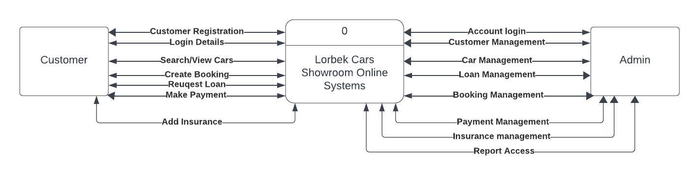

**USE CASE DIAGRAM**

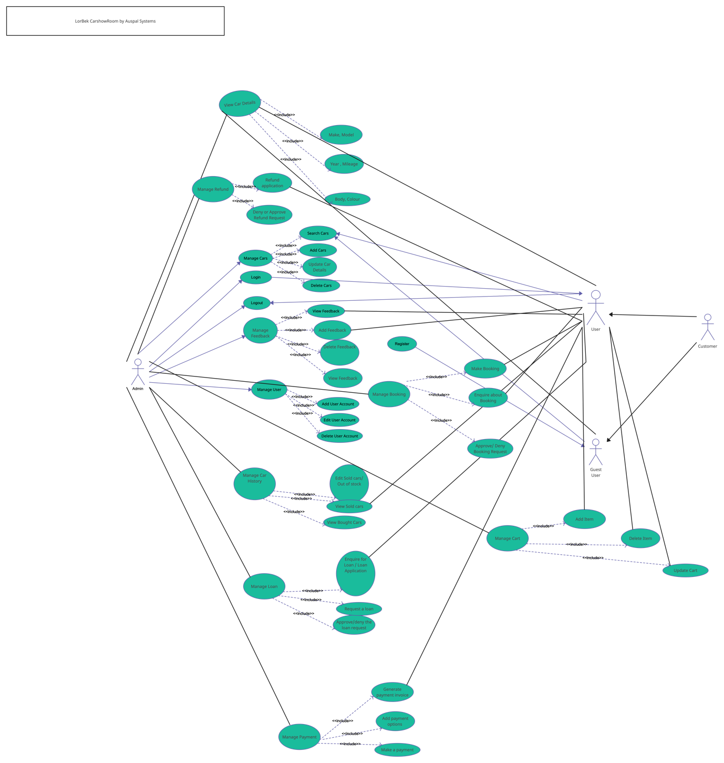

**DFD Level 2 for Car Management and Loan**

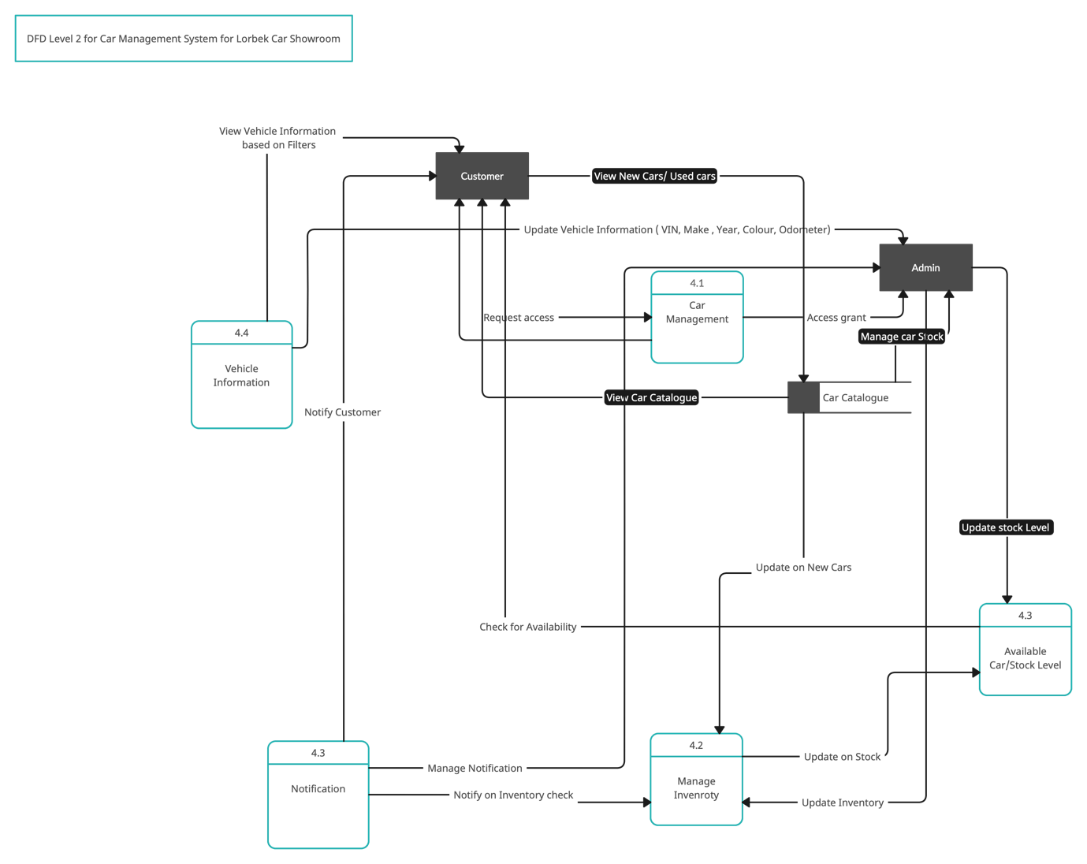

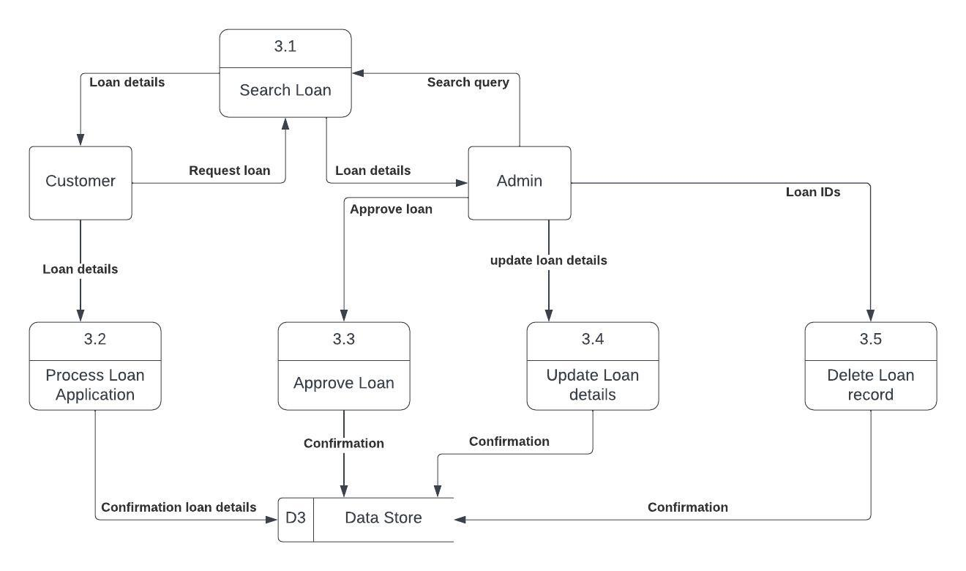

**Fig : DFD Level 2 for loan**

**UI design**

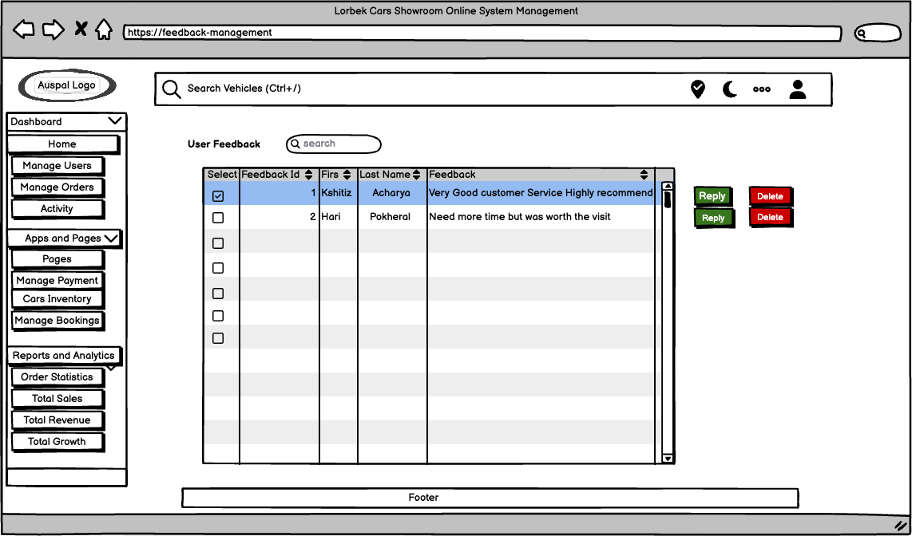

Fig : Manage Feedback

Fig: Chat Bot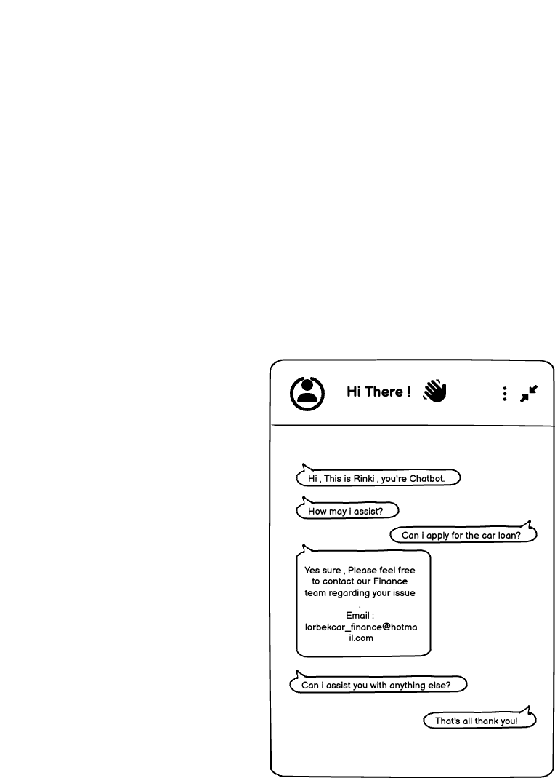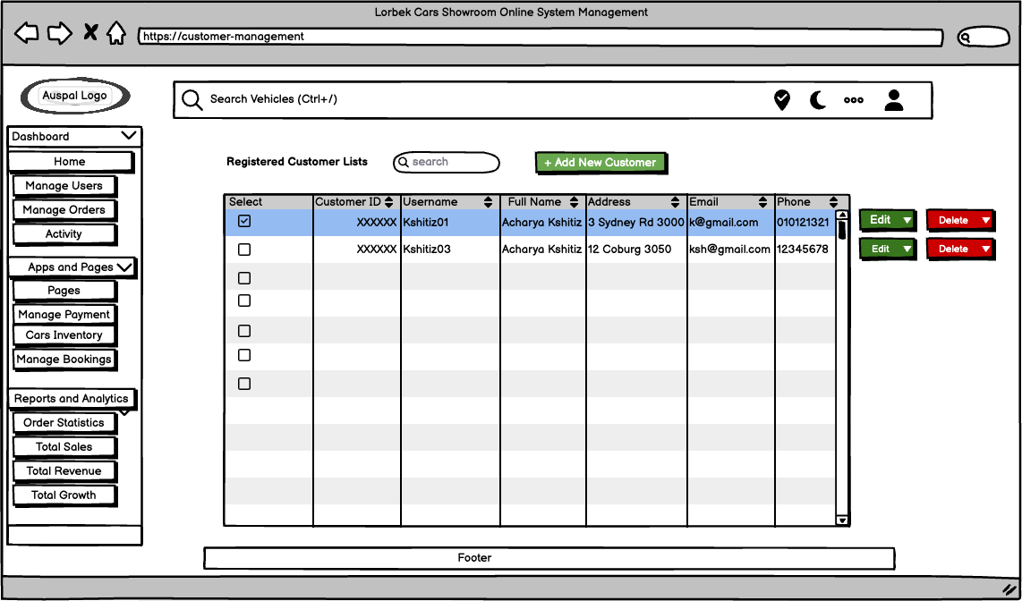

Fig: Manage Customer

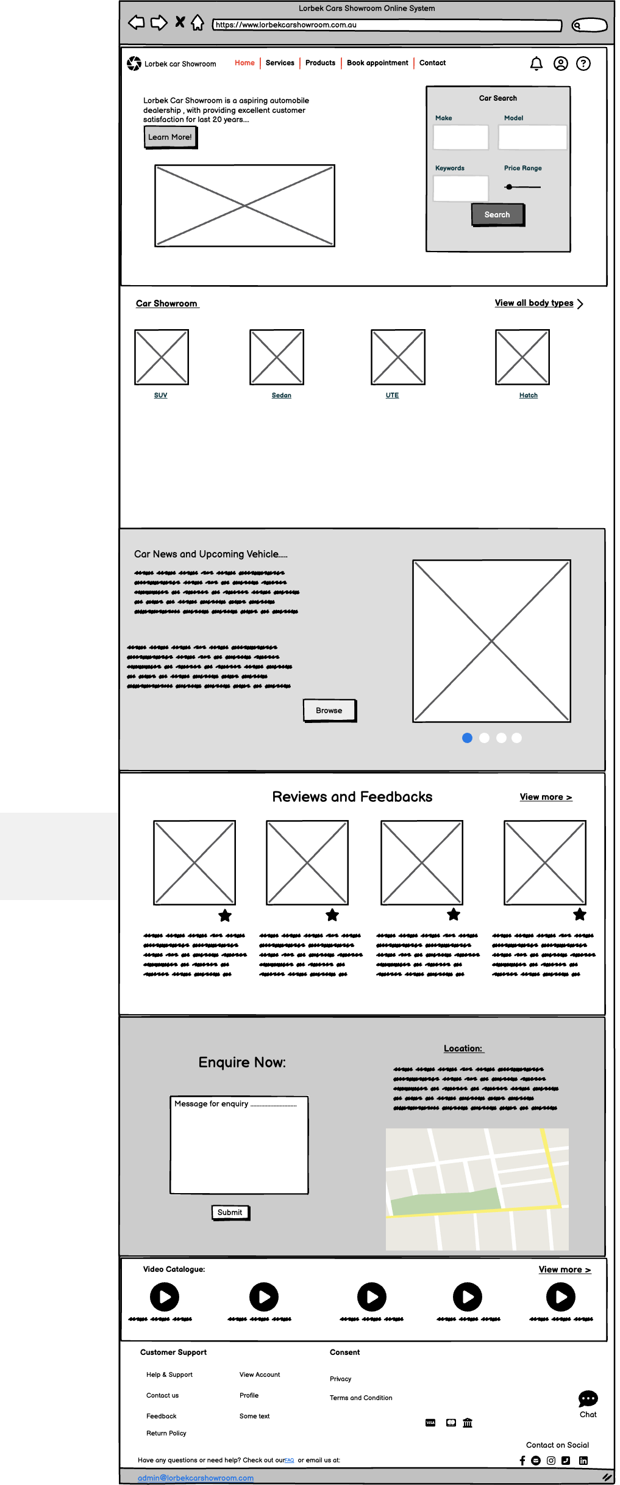Fig: Landing Page

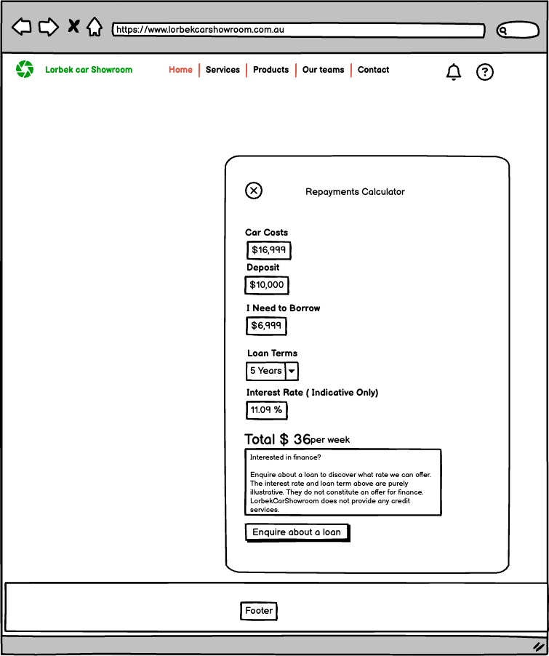

Fig: Repayment Calculator

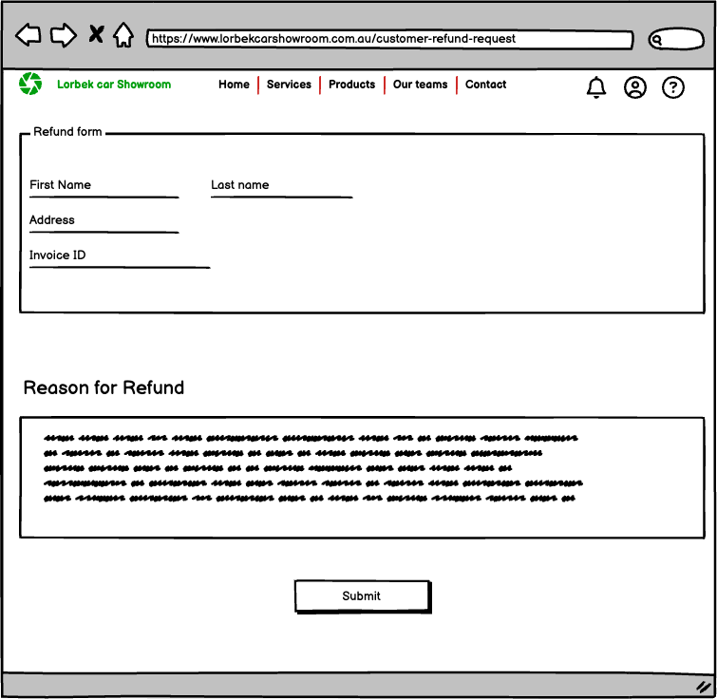

Fig: Refund Request form.

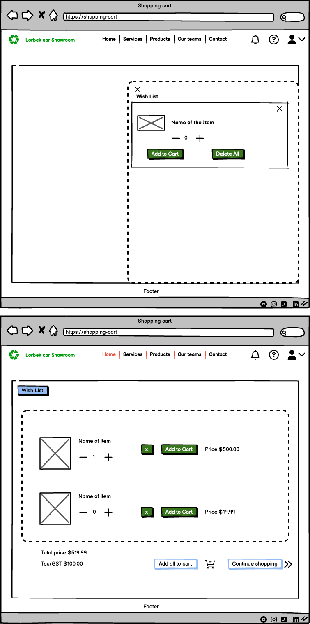Fig: Wishlist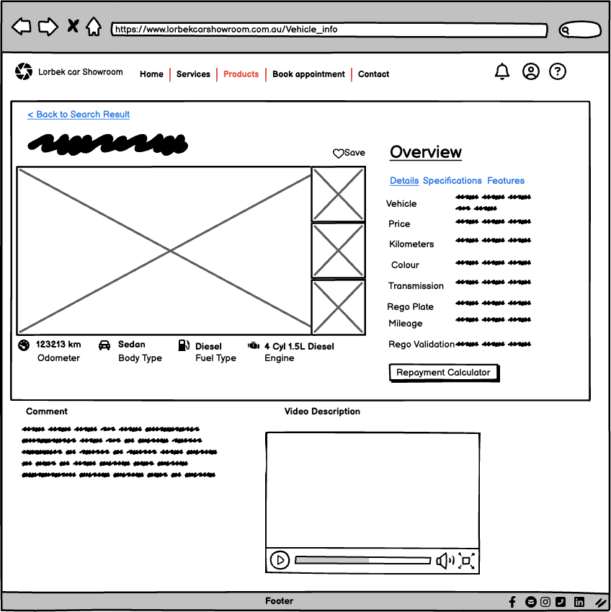

Fig: Vehicle Information